Using FeverPAIN score in your practice – TARGET antibiotics summary 2016
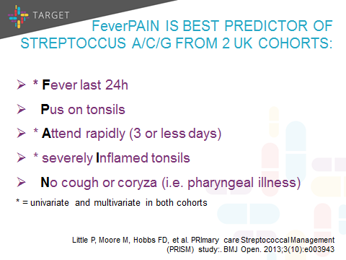
You can use the FeverPAIN scoring system for sore throat from this link.
PHE antibiotic guidance suggests you use the FeverPAIN score to guide antibiotic use in acute sore throat:
Score 0-1: 13-18% streptococci, use NO antibiotic strategy;
Score 2-3: 34-40% streptococci, use 3 day back-up antibiotic;
4 or more: 62-65% streptococci, use immediate antibiotic if severe, or 48hr short back-up prescription.
In a UK study the FeverPAIN score reduced antibiotic use by 29% (60/161, 37%) compared to a delayed antibiotic strategy (75/164, 46%), and the score was similar to using a Rapid Antigen Detection test for Group A streptococcus (58/164, 35%). Belief in antibiotics, and reconsultation were similar in the 3 groups.
The score was developed in a large cohort of UK General practice patients aged 5 years and over: As you can see 17% of patients with acute sore throat had a FeverPAIN score of 4 or over, and of these 62% had a Group A,C,or G streptococcus. In contrast 38% had a score of <1 and only 11-14% had streptococcus, which is similar to UK carriage rates.
